|  |
| --- |
| SCHOLARSHIP |
| Digital technology |
|  |
| Mai Nguyen | xxx | September 9, 2023 |

Table of content

1. Problem 1

2. solutions 1

Introduction

# 1. Problem

# 2. solutions

Tool used:

PLOTLY DASH:

Python is the programming language, Plotly and Dash are open-source libraries. Plotly is a module for python that is open-source used for data-visualisation that supports various graphs and chart types like line charts, scatter plots, bar charts,…Plotly produces interactive graphs that can be embedded on websites.[1] Dash is an opensource framework for building data visualization interfaces.

**There are 5 elements of a plotly dash code which is:**

* Library
* Dataset
* App layout
* Components
* Callback

Project approach:

Technical

Business

The principle is that cache, save and cache data source in local storage to improve performance and follow zero-trust rinciple risk broken link or data unavailable.

<https://youtu.be/uhxiXOTKzfs>

This video shows me the step-by-step guide to create a data visualisation dashboard using Panel/Hvplot package - source code for Python. The first step is to identify the issue then look for datasets online (Github, Tableau,...) then I will choose the tools, in this video she chooses Panel. The process includes: set up system, ideate dashboard, and code the dashboard using some source code from Panel package.

<https://youtu.be/hSPmj7mK6ng>

## Project management update

**28th March 2024:** I have finished the task “Present the Proposal” on March 28th, 2024. I also finished my second milestone “Present the Proposal” that was due on March 26, 2024. However, I extended the deadline to March 28th, 2024 and I finished on time.

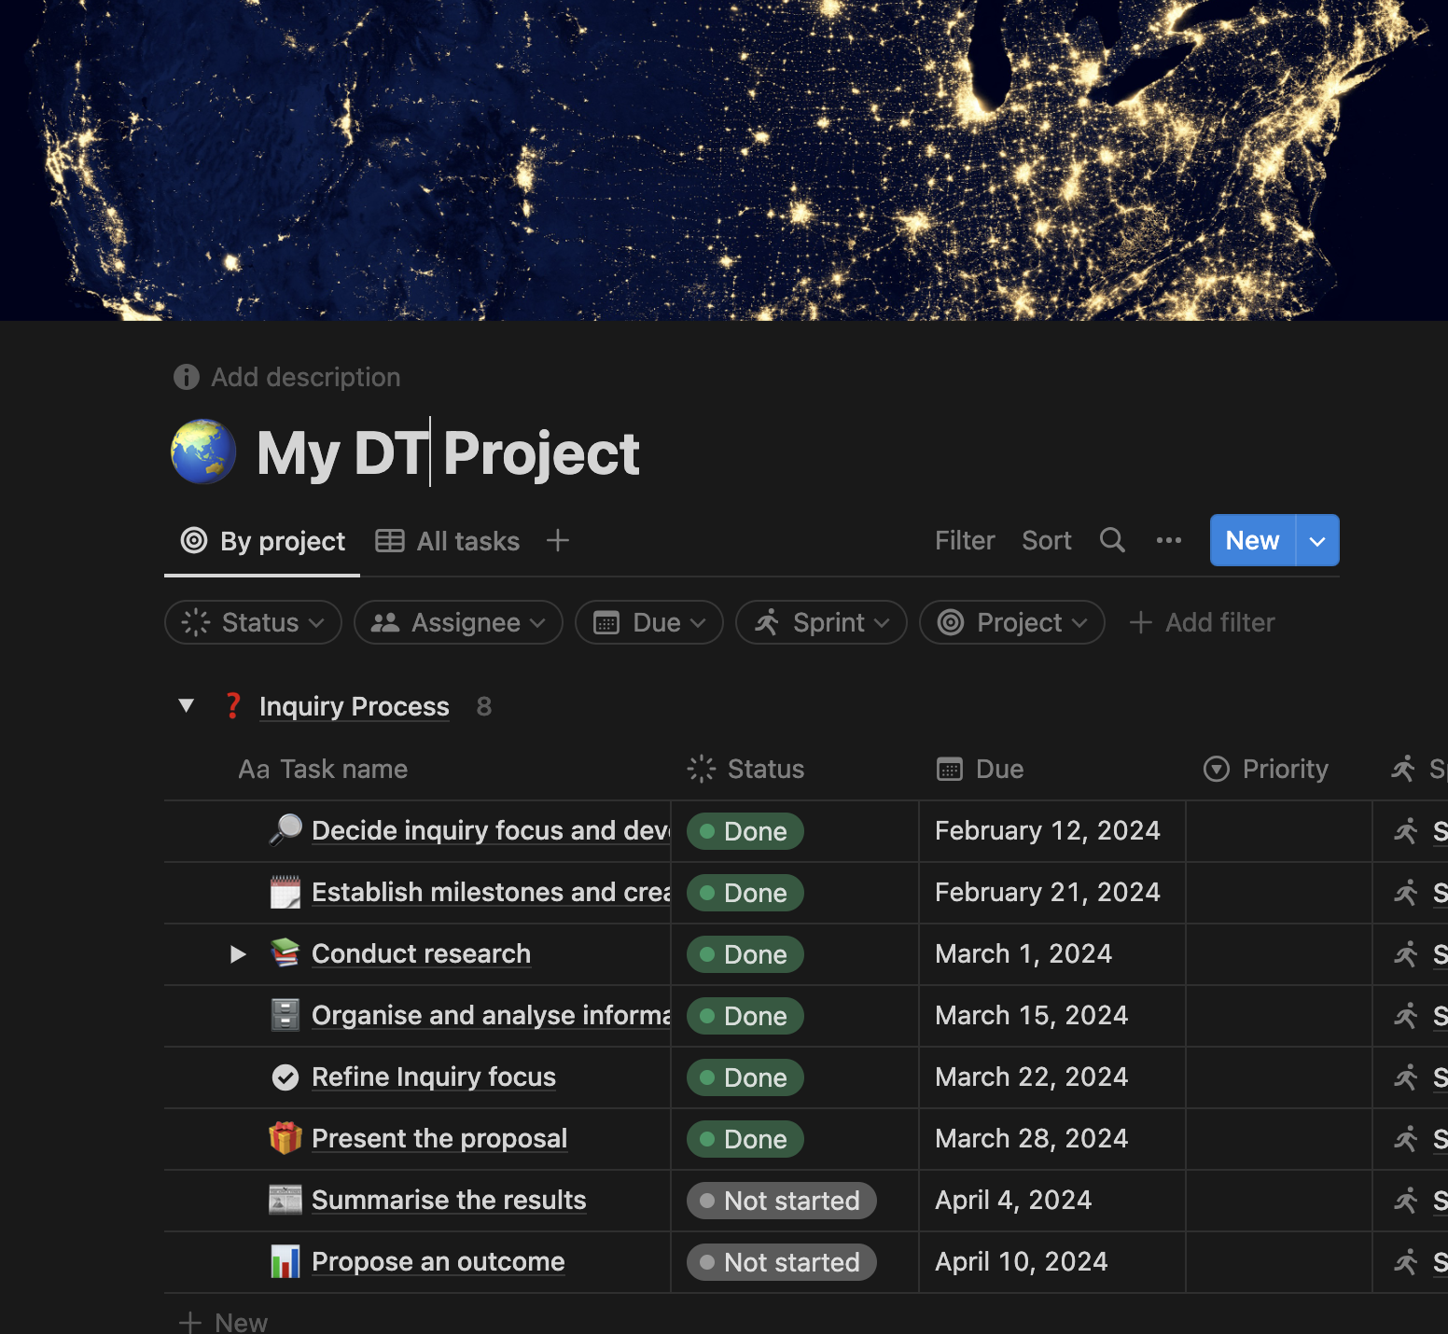

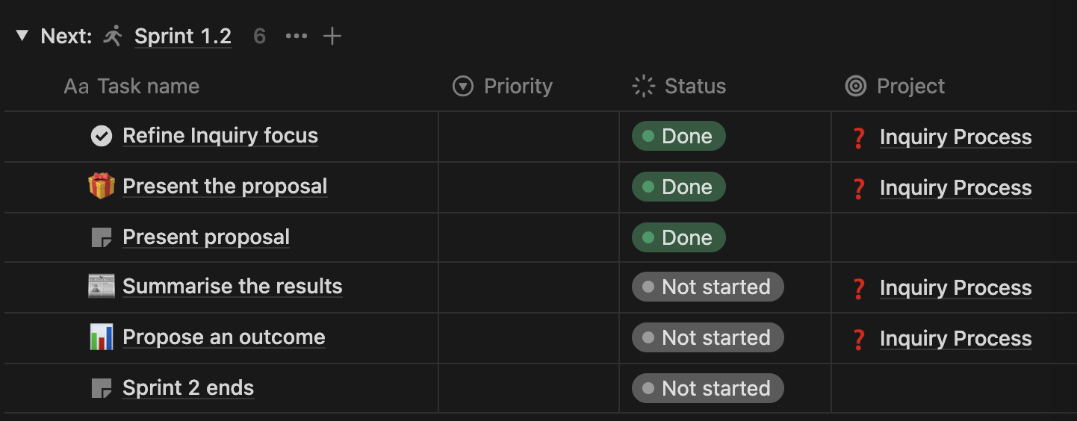 To meet my second milestone on time, I need to meet the next two deadlines for the tasks “Summarise the results” (April 1, 2024) and “propose an outcome” (April 10, 2024).

# Summaries the results

## Project management update

**April 4th 2024:** I have finished my “Summarise the results” task on time on April 4th 2024. I am almost to the end of Sprint 1.2, and my overall Inquiry Process so I must speed up my work to get things done.

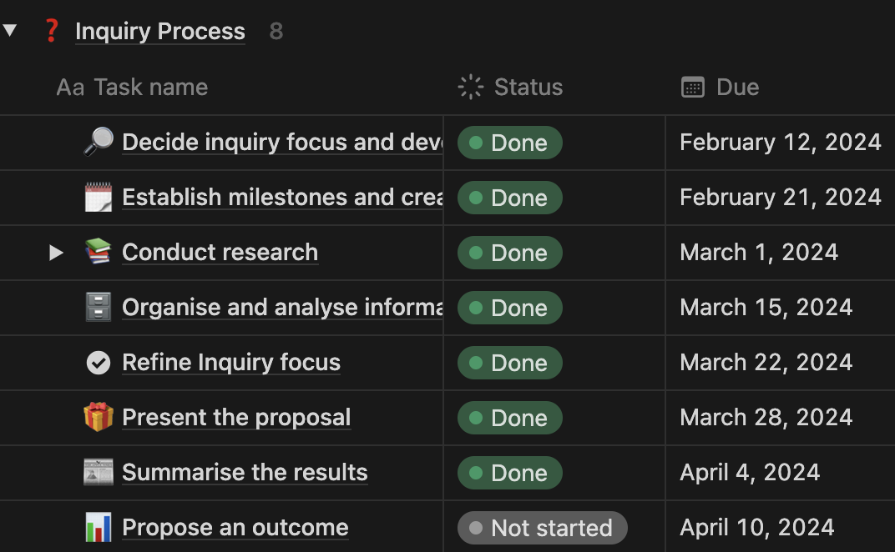

# Propose an outcome

## Project management update

**April 10th 2024:** I finished the “Propose an Outcome” task on the due date April 10th 2024. Also, I finished the last milestone “Sprint 2 ends” on the same day. I will check over my document for submission and finalise it on the 12th of April 2024.

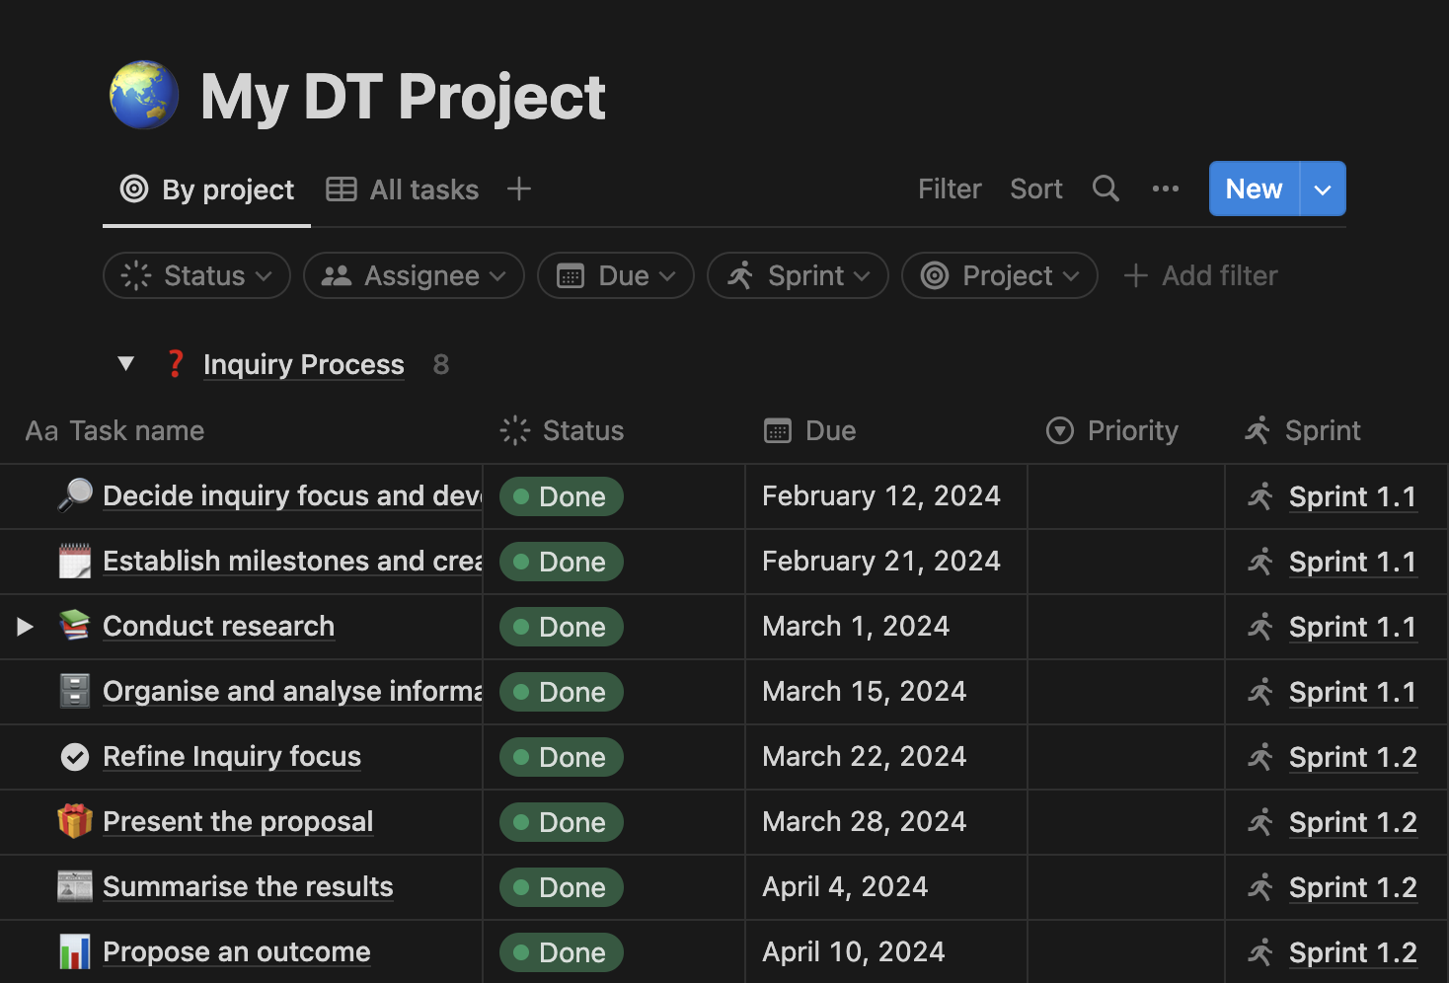

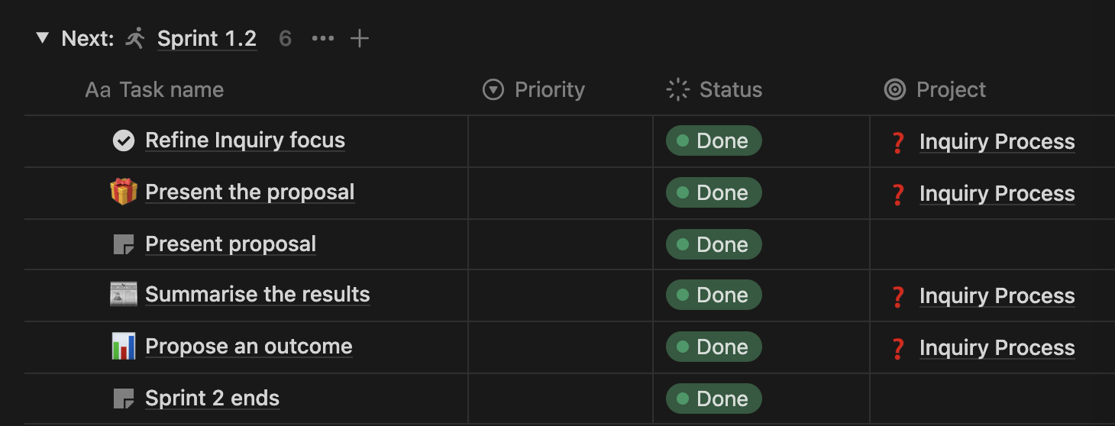

1. Majumder, P. (2023, September 25). *Guide to create interactive plots with plotly python*. Analytics Vidhya. https://www.analyticsvidhya.com/blog/2021/10/interactive-plots-in-python-with-plotly-a-complete-guide/#:~:text=Plotly%20is%20an%20open%2Dsource,variety%20of%20complex%20plotting%20options.